In Java 8, method references provide a shorthand syntax for calling methods or constructors using the :: operator. Method references are closely associated with functional interfaces and are used to simplify lambda expressions when the lambda's operation is already represented by an existing method.

Types of Method References
Java 8 supports four types of method references:

1. Reference to a Static Method
- Syntax: ClassName::staticMethod
- Used when a static method can directly perform the operation required by the lambda.
Example:
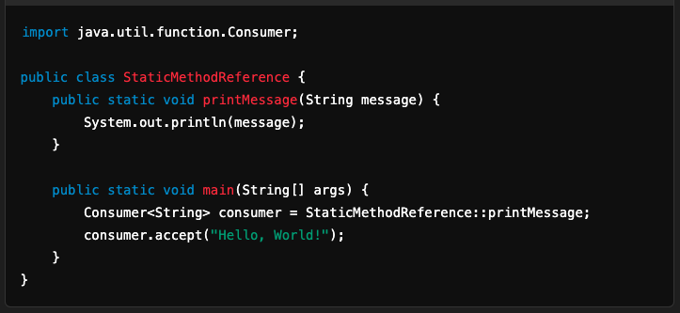
- Equivalent Lambda: (message) -> StaticMethodReference.printMessage(message)

2. Reference to an Instance Method of a Particular Object
- Syntax: instance::instanceMethod
- Used when an instance method can be invoked on a specific object.
Example:
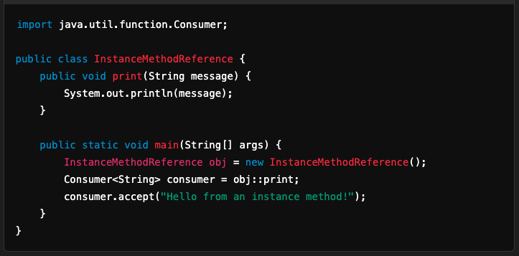
- Equivalent Lambda: (message) -> obj.print(message)

3. Reference to an Instance Method of an Arbitrary Object of a Particular Type
- Syntax: ClassName::instanceMethod
- Used when an instance method is called on different objects of the same class.
Example:
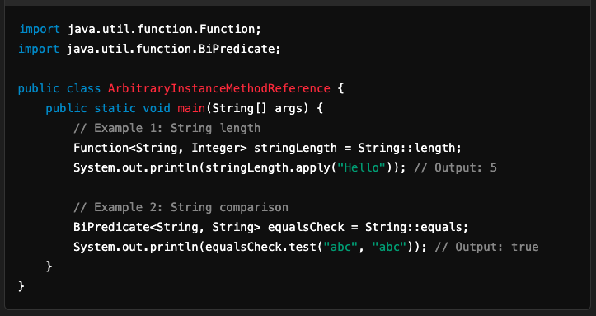
- Equivalent Lambda: (str) -> str.length()

4. Reference to a Constructor
- Syntax: ClassName::new
- Used to create a new object using a constructor.
Example:
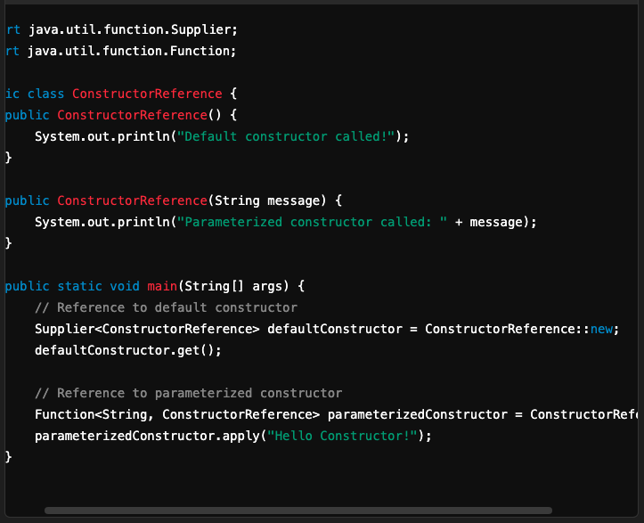
- Equivalent Lambda: () -> new ConstructorReference() or (message) -> new ConstructorReference(message)

Comparison with Lambda Expressions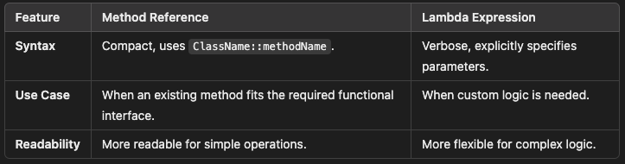

Conclusion
- Method references are syntactic sugar for lambda expressions and improve code readability.
- They are ideal when you already have a method that matches the signature of the functional interface you are using.
- Use the appropriate type of method reference based on the context and the operation being performed.

